Using Smart Phones for Data Collection

A teaching guide

Objectives:
This exercise aims to teach that:
- All Android phones can be used for data collection.
- Training is easy and all can learn really fast.
- Data collection from the field in many formats can be done using Android phones.
- Simple surveys/data can be entered using smart phones. For longer, complex surveys a larger screen of a tablet may be required.
- Different forms, based on various needs, can be created and amended easily.
- Local languages can be used.
- Location and photo data can be captured. Capture of location data does not need tower coverage.
- Mobile data or wifi connection is not needed at the time of data collection. The collected data can be sent once the phone is within coverage or when wifi is available.
- The uploaded data can be seen at the site as per instructions given below. It can be password-protected or made open to the public. It can also then be downloaded into an Excel sheet for further analysis.
- ODK is one free application available. There are several others, with varying features, that can also be used.
- Android phone application is used because the phone is widely available and affordable/inexpensive. Apple phones can’t be used with this application directly (although indirectly is possible).
- The software is free. There is no cost of buying or using or maintaining.
- Most government employees already have Android phones. Various ideas can be rolled out without any new hardware expense.
This simple process has many applications in government in administration, health, policing, municipal services, local development, education, agriculture, construction etc. Installing ODK on Android mobile handset

How to configure mobile application

Open Android Playstore, search ‘ODK Collect’ and click on the app that has this 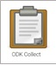 logo, accept the download and install the application. | 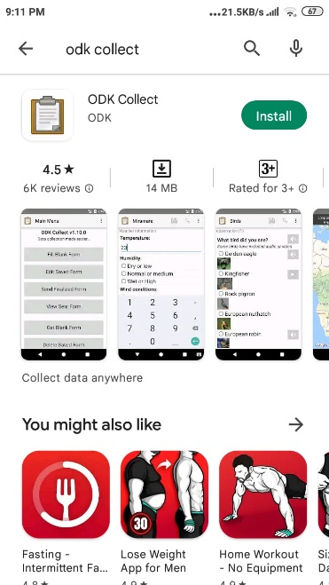
Once installed, tap the icon on the phone and open the app. | 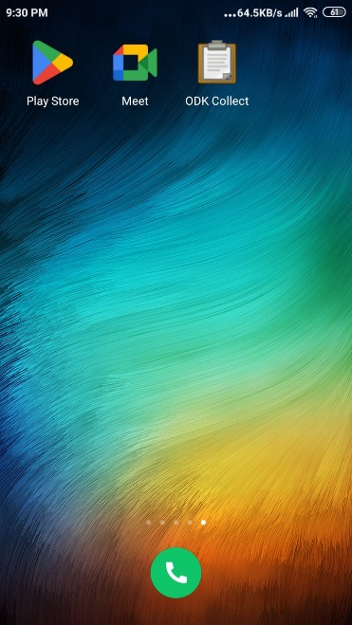
When the application opens, click the CONFIGURE THROUGH QR CODE button. | 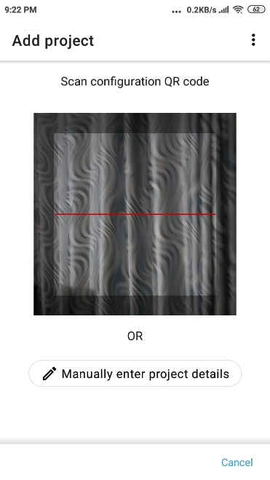
Point your camera to following QR code:  (This is a project specific code for Madagascar Birth Registration Form). | 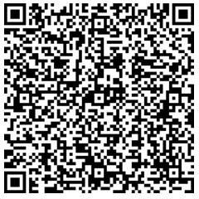
The application will pick up and load all the settings automatically, and will be ready to use. | 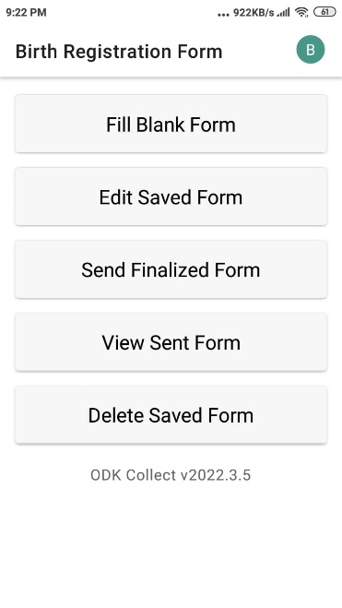

How to browse to the form and fill the data

Press FILL BLANK FORM button. From the list, select the BIRTH REGISTRATION FORM.  Note: If you cannot see the form, please click the REFRESH button on the top menu (the circular arrow). It will download the latest version of the form from the server. | 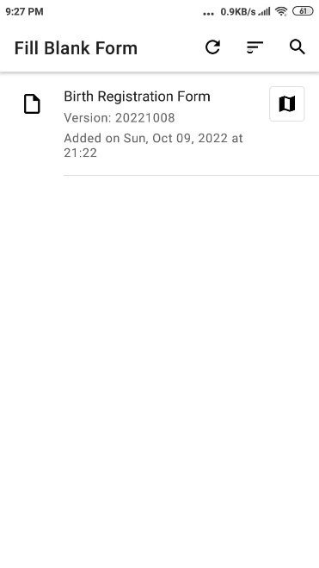
The data collection will start with an introduction text screen. Swipe from right to left to start the form filling process and moving to the next screen. | 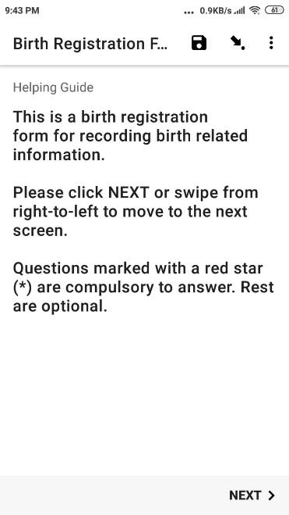
Answer all questions. You cannot leave the required questions blank. If you swipe without answering a compulsory question (marked with red star *), the app will show “Sorry, this response is required” message. | 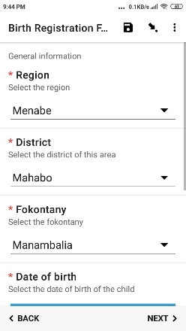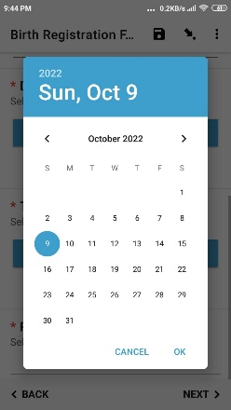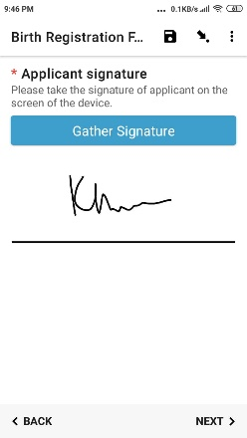
When you reach the end, press the button SAVE FORM AND EXIT. | 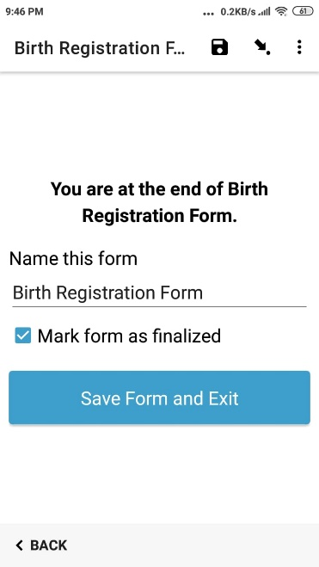
The data collection process is complete.

The application is configured to send the data automatically to the backend server, whenever it finds a good internet connection.

You can see the data at the dashboard as given below.

How to check the data on the server (For admin only)
ODK dashboard is called ODK Central. It is a password protected web portal which stores and displays all data sent from the field.
- For our project (Madagascar Birth Registration):
  - Access: https://odkmg.govtech.solutions (click to open in a browser)
    - Username: demo@abc.com
    - Password: demo@24680
- From PROJECTS section, select the BIRTH REGISTRATION FORM. Next, in the FORMS section, click BIRTH REGISTRATION FORM.
- In the SUBMISSIONS tab, you will be able to see all the data submitted by the field.
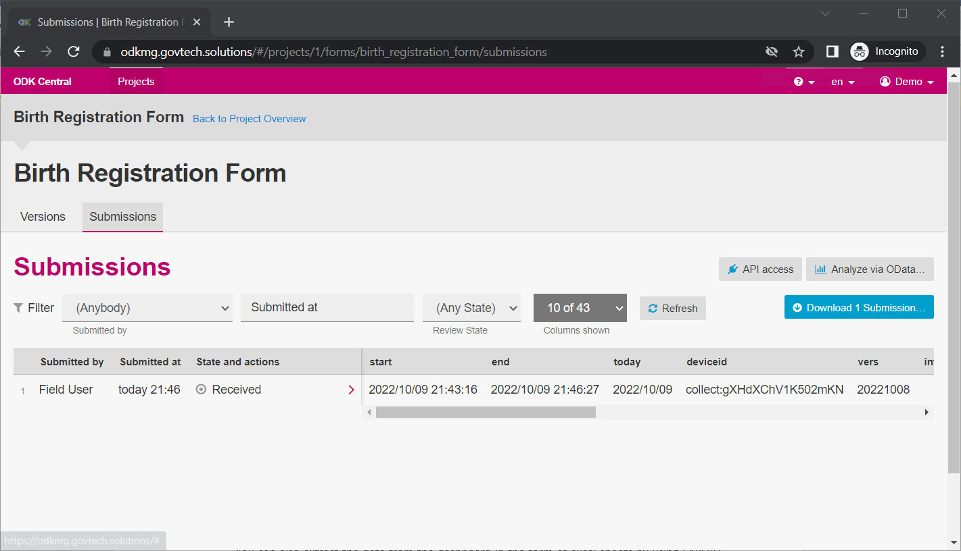
- You can also extract the data from the dashboard in the form of excel sheets by using DOWNLOAD SUBMISSIONS button at the top right corner.

ODK is a world class application suite to perform data collection from the field. You can find more information and learn how to develop your own forms as below.
http://www.getodk.org

